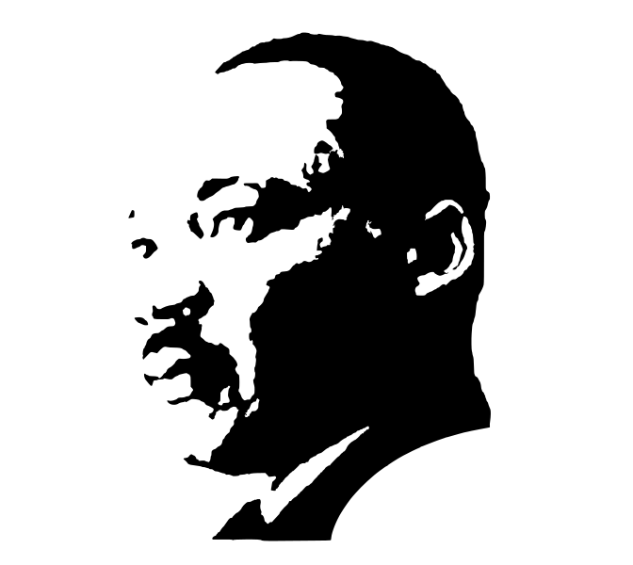
2024 Martin Luther King Day Student Contest
sponsored by Africana Studies and College of FHSS

On April 19, 1961, Dr. Martin Luther King Jr. gave a talk at The Southern Baptist Theological Seminary entitled, “The Church on the Frontier of Racial Tension.” In this speech he addressed the question: “How can every church fight for racial reconciliation?” His answer included the following points:
- Develop a global worldview;
- Teach that segregation is evil;
- Silence false ideas about race;
- Establish communication between races;
- Integrate the church;
- Repent and forgive one another;

Read the full transcript and/or listen to the speech: https://equip.sbts.edu/audio/full-text-church-frontier-racial-tension/

Reflect on King’s words and then share your thoughts about how they relate to the work of reconciliation in our communities today in an essay of 777 words or less, a poem, a song, a 5–10-minute film, or another work of visual art. Submissions which demonstrate engagement with King’s words and belonging work at BYU in a clear and creative way will be awarded prizes!

DEADLINE: Submit your essay by January 10, 2024 11:59 pm to: africana@byu.edu as an attachment or link. Please include the following information with your submission: your name, year in school, major, minor(s), hometown, email address, and phone number.

The first-place winner will receive $1,000 and the opportunity to present their work at BYU’s MLK Walk of Life Commemoration on Wednesday January 17, 2024. The second and third place winners will receive $750 and $500, respectively. (Previous first-place winners are not eligible for the same award in consecutive years.) Questions about the essay contest can be directed to the above email or to Dr. Leslie Hadfield leslie_hadfield@byu.edu, the Africana Studies Coordinator.

